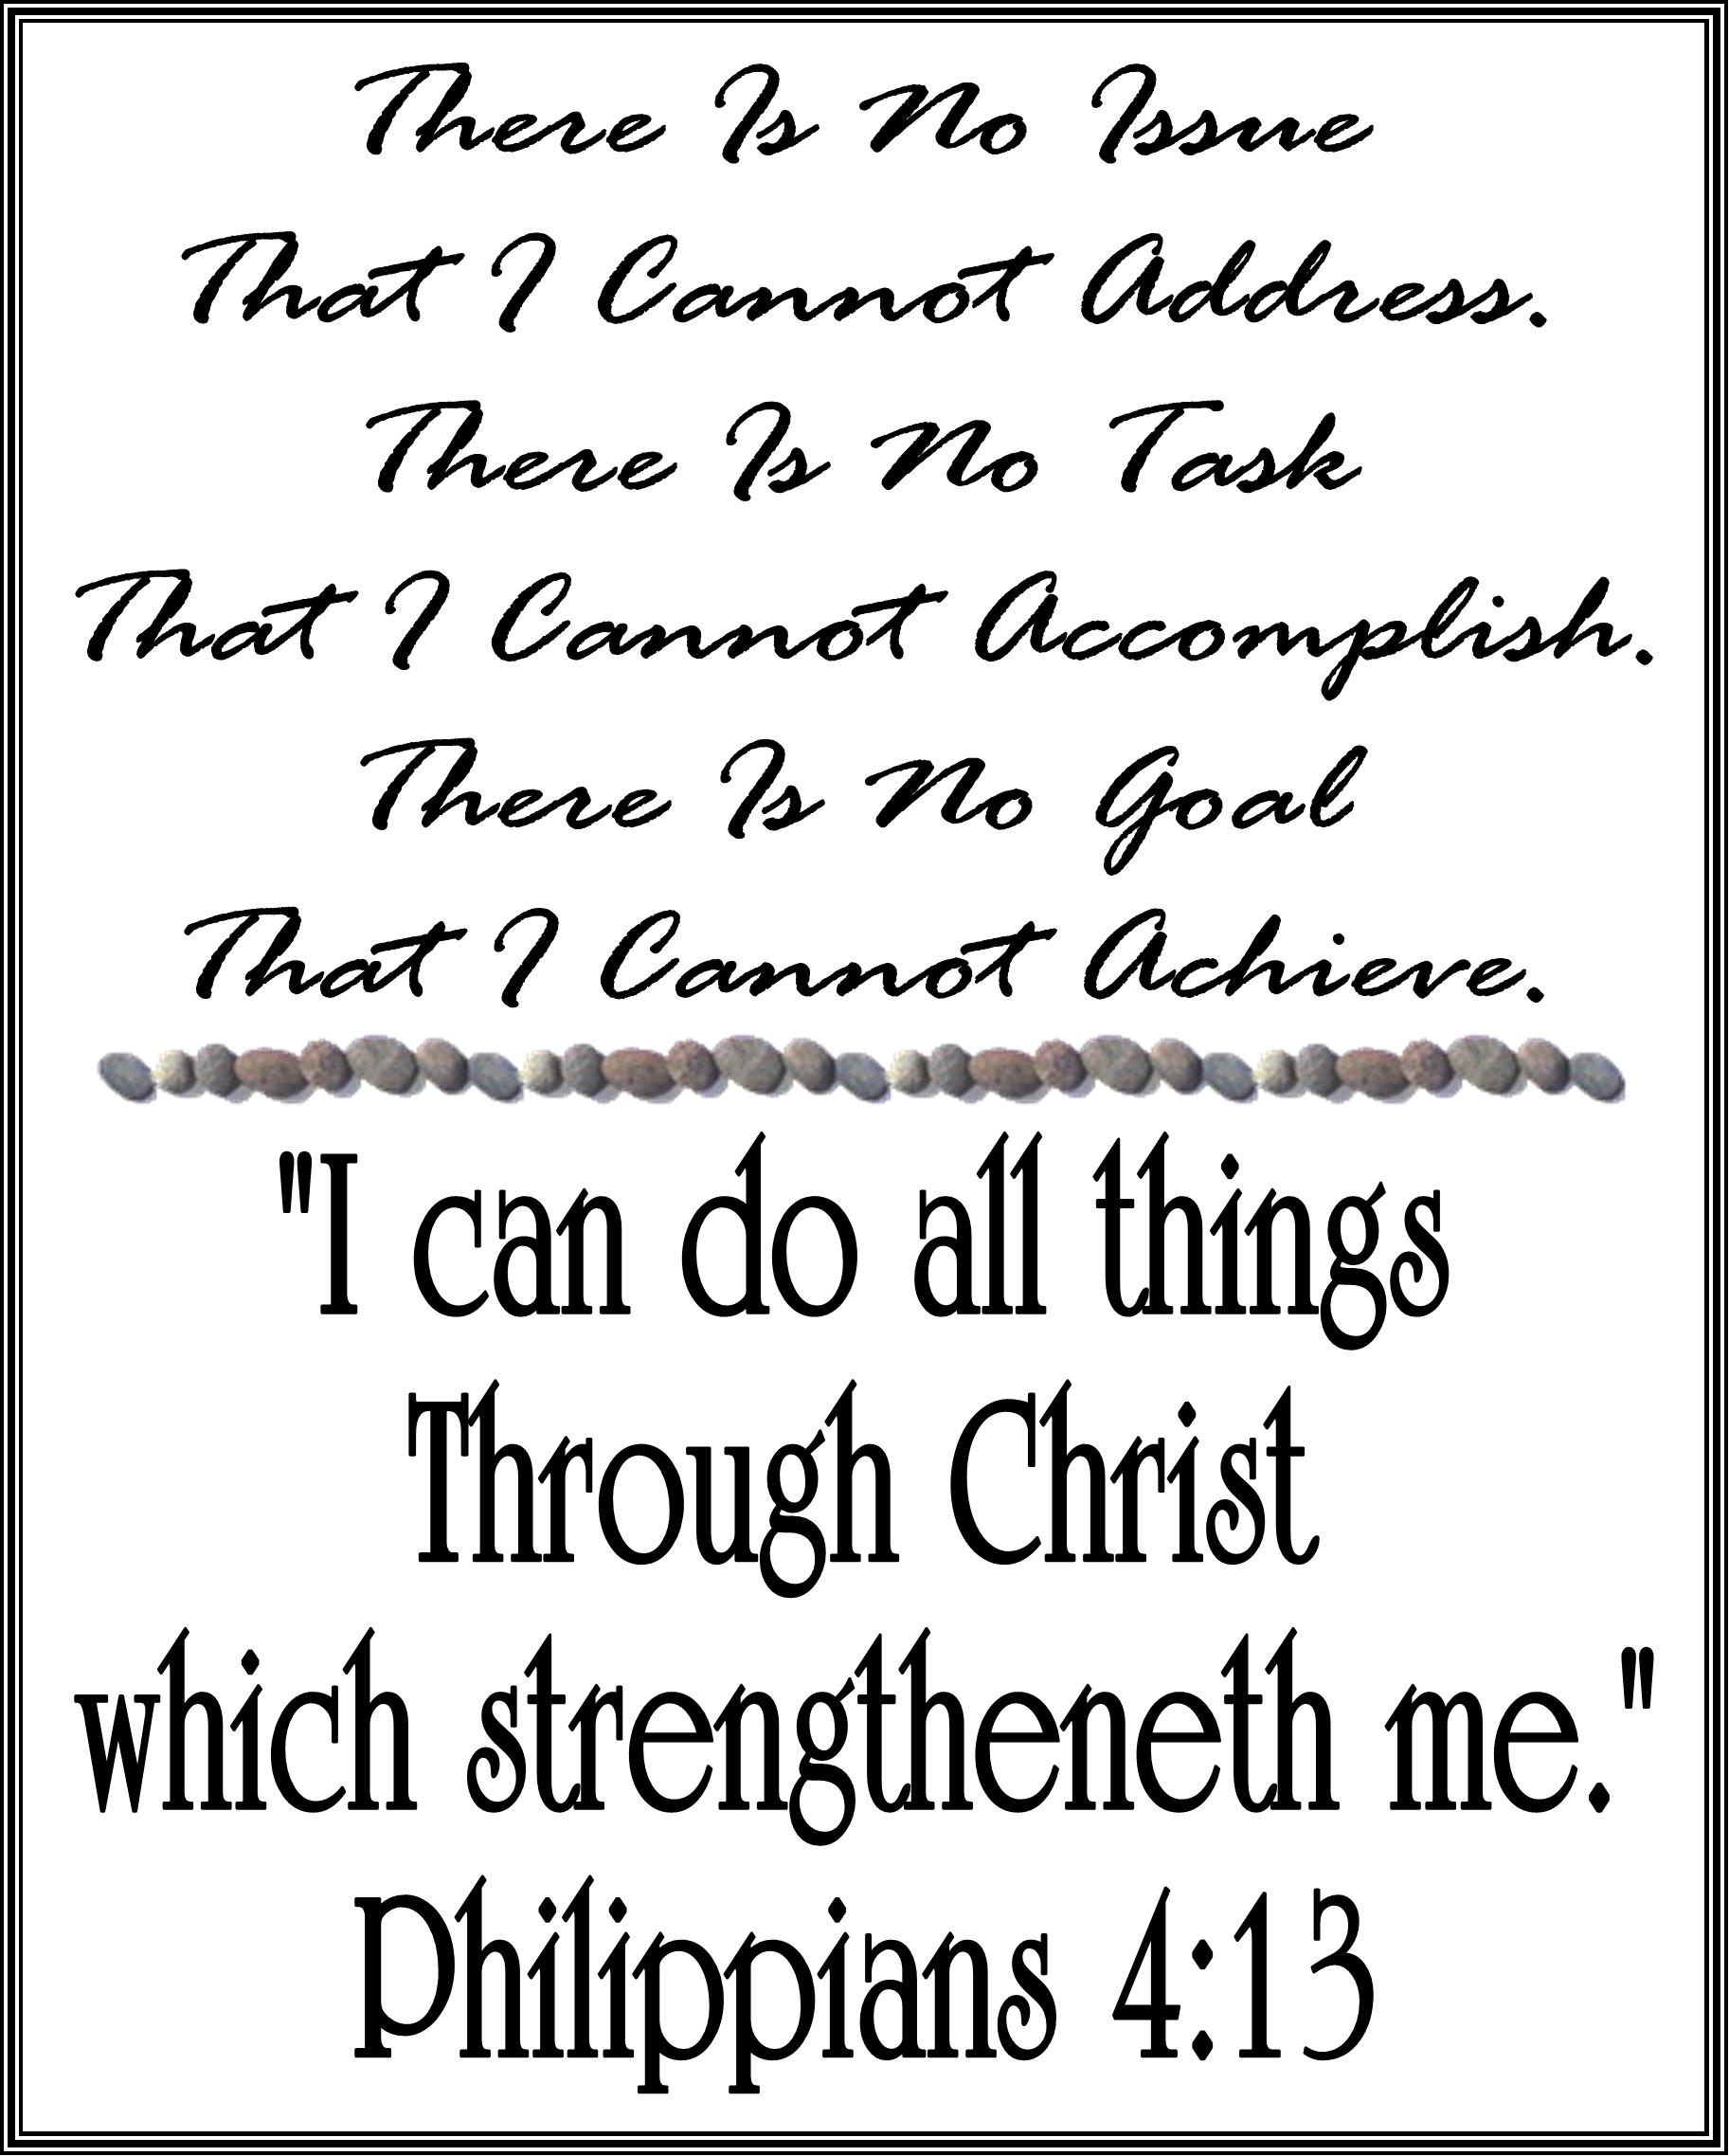
Jesus Christ; The Same…
Hebrews 13:8, 15-16
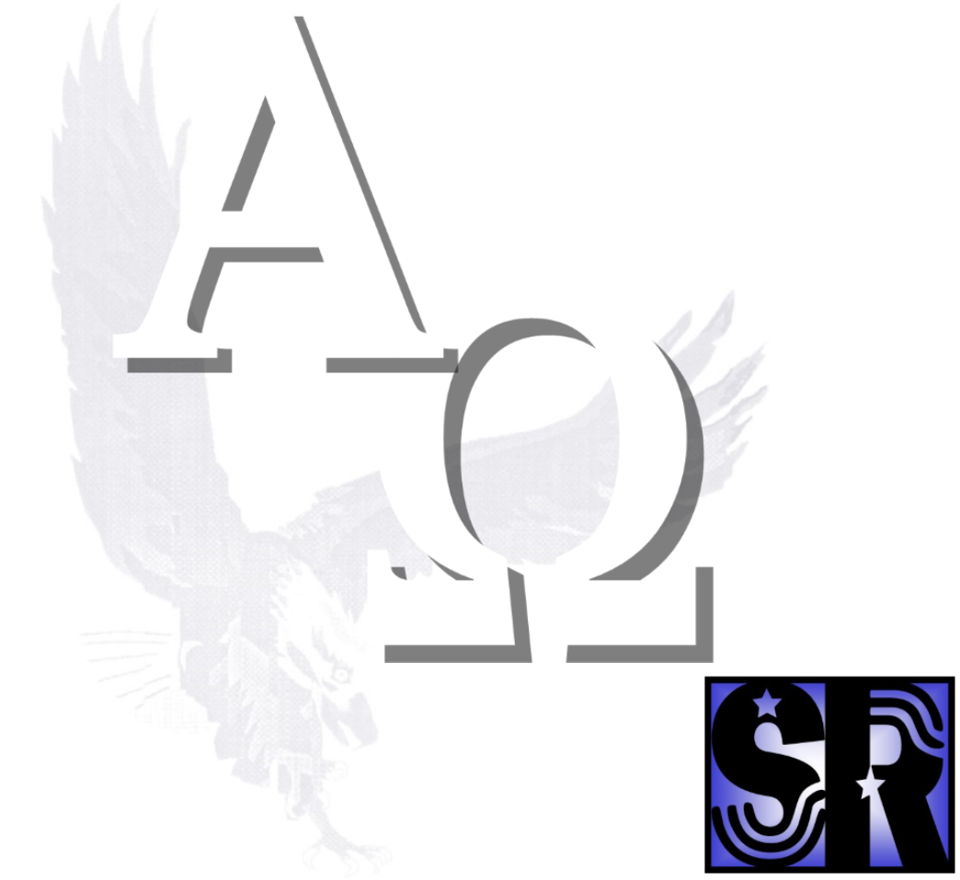

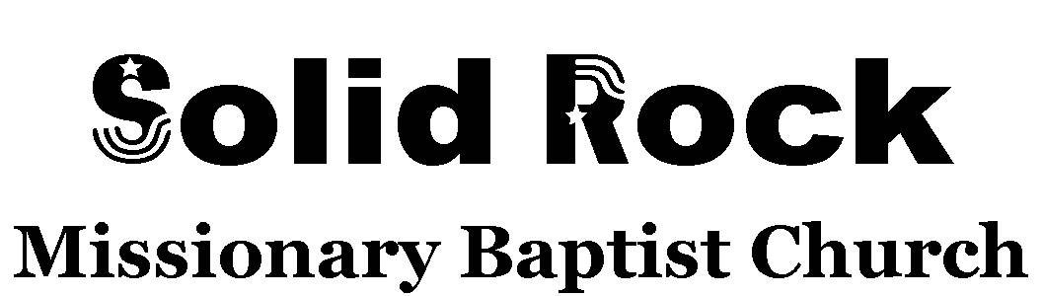

Bishop Samuel A. L. Pope, Sr.
Pastor
760.373.1782
P. O. Box 2416, California City, California 93504
On Christ the Solid Rock we stand.
Come; make your stand with us.
Jesus Christ; The Same…

Heb 13:8, 15-16;
(8) “Jesus Christ the same yesterday, and today, and for ever.”

For:
Whatever;
Whenever;
Wherever;
Whichever;
Whosoever;
Why-ever;
And How-so-ever.
For Every:
Affliction;
Alienation;
Allegation;
Askance Glance;
Circumstance;
Complication;
Consequence;
Deception;
Decision;
Deviation;
Disappointment;

Incidence;
Insinuation;
Intimidation;
Mountain;
Obligation;
Ramification;
Situation;
And Valley.
For Every:
Second; Minute; Moment; Hour;
Li’l While; Time; Day; Night;
Morning; Noon; Evening; Midnight;
Shut In; Shut Out; Shut Up; Shut Down;
Man and Woman; Boy and Girl;
High and Low; In and Out;
Mole Hill; Mole Hole;
Down and Out; Fear and Shed Tear;
Pain and Strain; Loss and Gain.

(15) “By Him therefore let us offer the sacrifice of praise to God continually, that is, the fruit of our lips giving thanks to His name.
(16) But to do good and to communicate forget not: for with such sacrifices God is well pleased.”

